Software Requirements Specification
for
Bus Management System
Prepared By:
1 | Varun Parashar | 1701074
2 | Shivam Anand | 1701062
3 | Swapnil Raj | 1701072
4 | Rushikesh Shimpi | 1701055
5 | Subhash Kumar Suman | 1701067

Indian Institute of Information Technology Guwahati
23.01.2020
Table of Contents
Table of Contents ii
Revision History ii
1. Introduction 1
1.1 Purpose 1
1.2 Intended Audience and Reading Suggestions 1
1.3 Product Scope 1
1.4 References 2
2. Overall Description 2
2.1 Product Perspective 2
2.2 Product Functions 2
2.3 User Classes and Characteristics 3
2.4 Operating Environment 3
2.5 Design and Implementation Constraints 3
2.6 Assumptions and Dependencies 4
3. External Interface Requirements 5
3.1 User Interfaces 5
3.2 Hardware Interfaces 5
3.3 Software Interfaces 5
3.4 Communications Interfaces 6
4. System Features 7
4.1 System Feature 1 7
5. Other Nonfunctional Requirements 9
5.1 Performance Requirements 9
5.2 Data Requirements...............................................................................................................9
5.3 Safety Requirements 9
5.4 Security Requirements 10
5.5 Software Quality Attributes 10
Appendix A: Data Dictionary 10
Appendix B: Group Log 10
Appendix C: Limitations 10

Revision History
Name | Date | Reason For Changes | Version
Bus Adda | 15.01.2020 | New | 1.0
Bus Adda 1.1 | 23.01.2020 | Update in limitations and app features | 1.1

Introduction

Purpose
The Main aim of Bus Management project is to ease the process of ticket

booking and keeping records of buses and the drivers or the conductors.

We aim to demonstrate the use of create, read, update and delete MySQL

operations through this project. This project starts by adding stations then

adding details of employee either a driver or a conductor. Once,

registration is done user can add bus details with the route. Now, the user

can use the ticket counter to book tickets for the passengers.

Intended Audience and Reading Suggestions

Who are unable to buy bus ticket online at this moment would have to go to the counter to a buy bus ticket. Sometimes, customers’ needs to queue up a long queue to buy bus ticket and ask for information and this brings a lot of inconveniences to customers. Online Bus Ticket Reservation System enables the customer to buy bus ticket, make payment, and ask for information online easily.

Product Scope

The main purpose of this study is to automate the manual procedures of reserving a bus ticket for any journey .This system is said to be an automatic system and customers can select seats by themselves. Specifically, objectives of this project will consist of:

i) Providing a web-based bus ticket reservation function where a customer can buy bus ticket through the online system without a need to queue up at the counter to purchase a bus ticket.

ii) Enabling customers to check the availability and types of buses online. Customer can check the time departure for every bus through the system.

iii) Easing bus ticket payment by obtaining a bank pin after payments is made to our designated banks.

iv) Ability of customers to cancel their reservation.
v) There will be reserved seats for senior citizens.

vi) There will be a panic button in the app which will trigger our alarm system, for case of emergency.

vii) Admin user privileges in updating and canceling payment, route and vehicle records.
viii) A driver or a conductor can be added by a user with admin privileges. On the other hand, a user with roles such as Driver or conductor will login with their user-names and password to find about their current journey.

References

IEEE SRS Format.

Overall Description

Product Perspective

This project is a tool to help in managing bus services. It is more useful in current market situation where an organization is not close to a door or a city or a nation. In this case user can book ticket from one corner of the world to another by using internet makes our work for easy.

Product Function

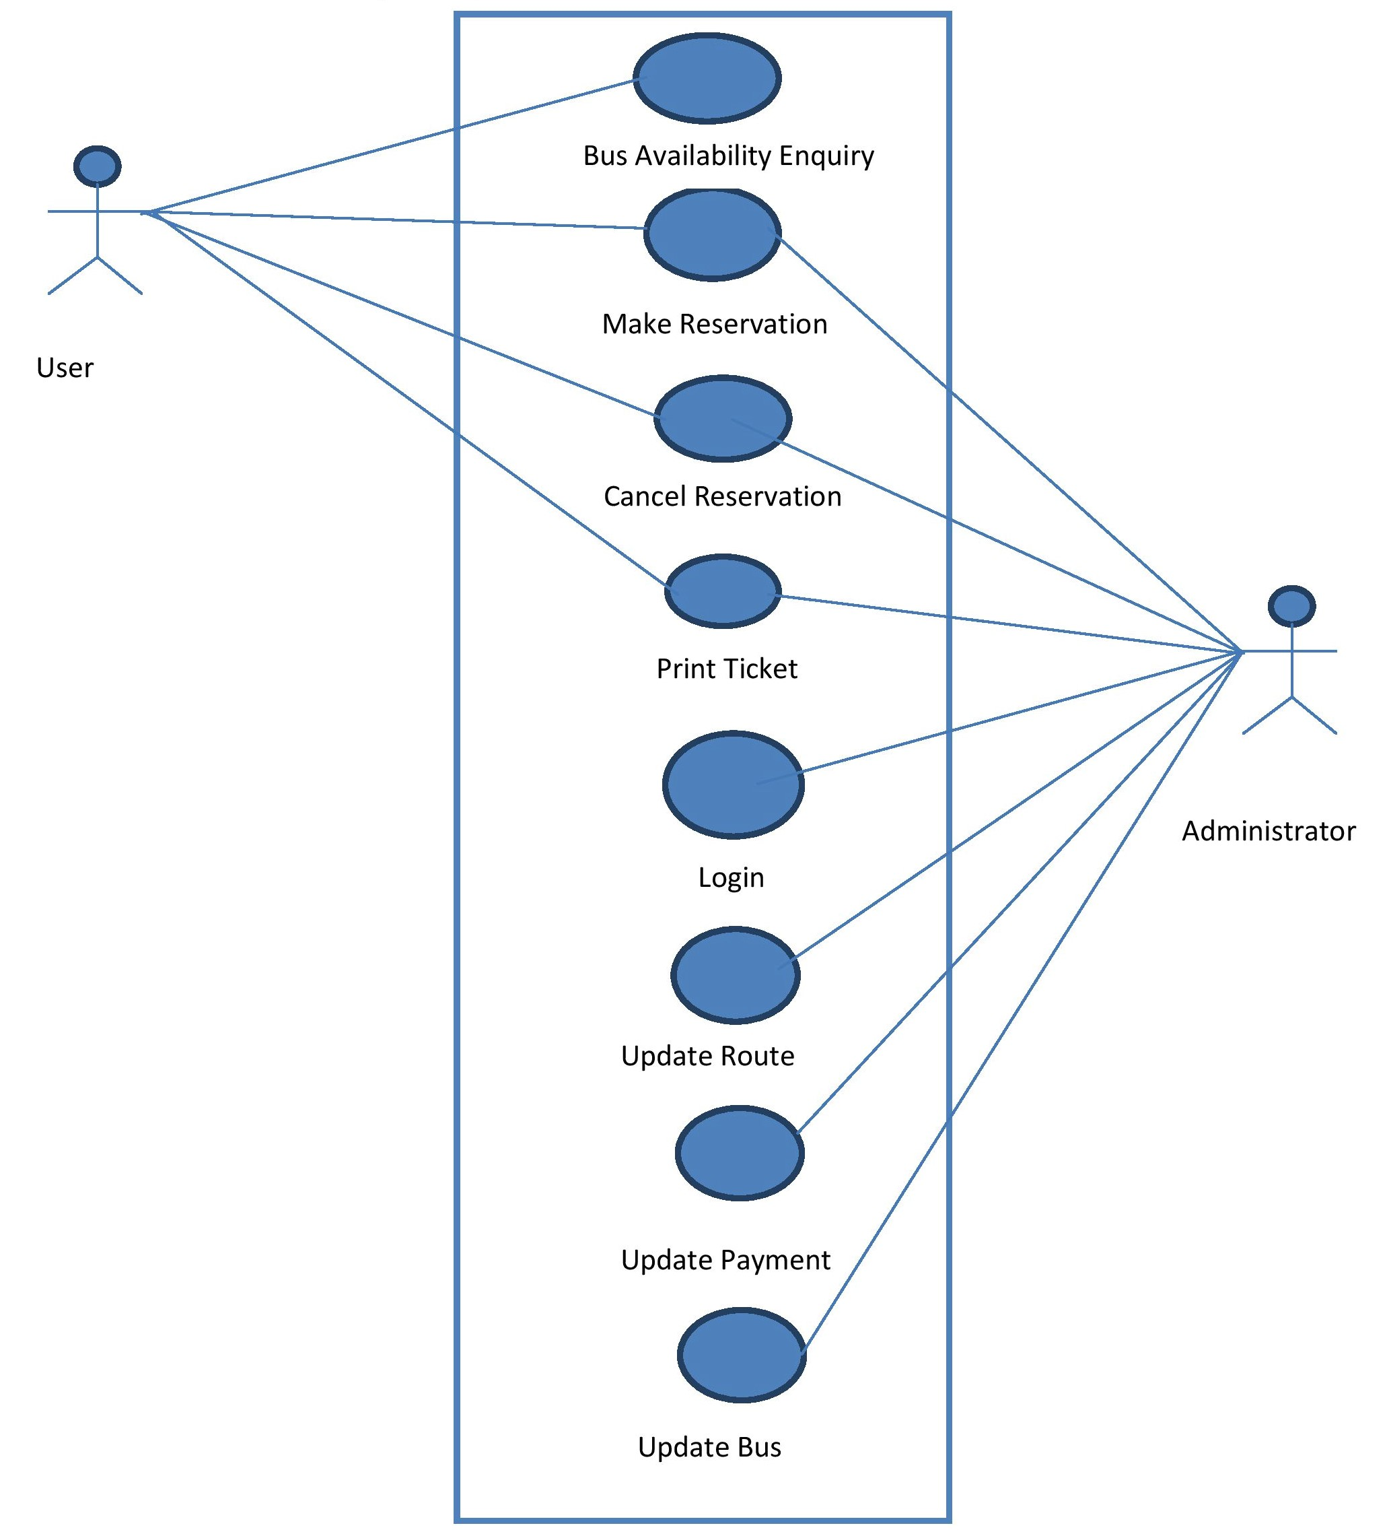

User Classes and Characteristics
Admin:
This class of users can make reservation, cancel reservation, print ticket of any user ,remove existing user from database ,update Route, update payment mode, add and remove buses.
Customer:
This class of users can reserve ticket for journey by buying ticket or cancel an already booked ticket and can print ticket.

Operating Environment
Operating environment for the bus management system is as listed below.
- client/server system
- Operating system: Windows.
- database: SQL database ( MySql )
- platform: Python /Django(Web Frameworks) /Java /PHP

Design and Implementation Constraints
- SQL commands for above queries/applications
- How the response for application 1 and 2 will be generated. Assuming these are global queries. Explain how various fragments will be combined to do so.
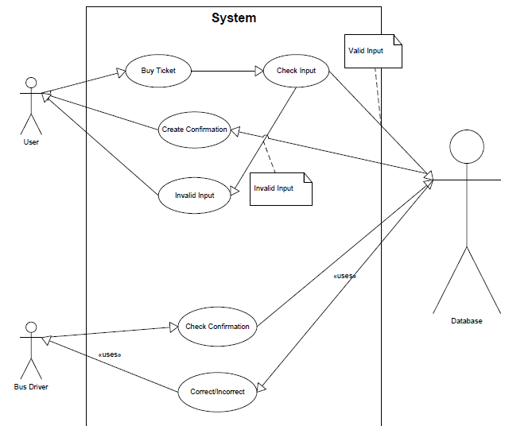
- Implement the database at least using a centralized database management system.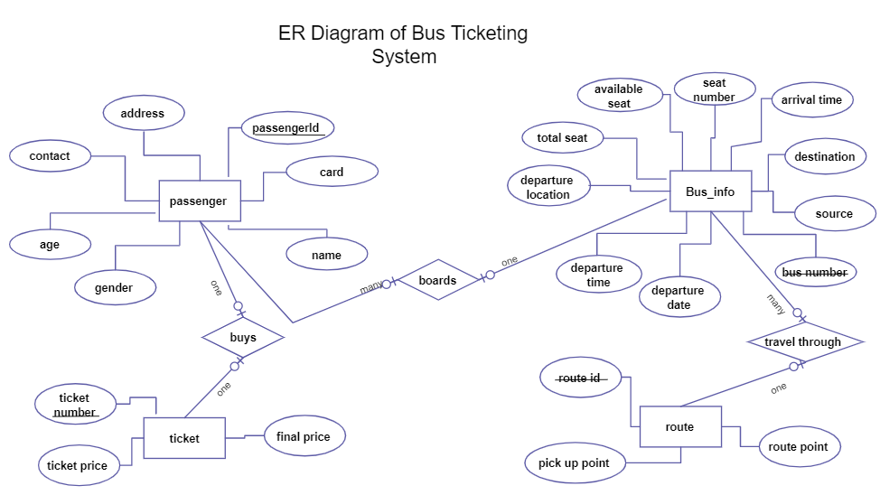

Assumptions and Dependencies
Let us assume that this is a distributed bus management system and it is used in the following application:
- A request for booking/cancellation of a bus from any source to any destination, giving connected buses in case no direct bus between the specified Source-Destination pair exist.

- Calculation of high travellers (most frequent travellers) and calculating appropriate reward points for these travellers.

External Interface Requirements

User Interfaces

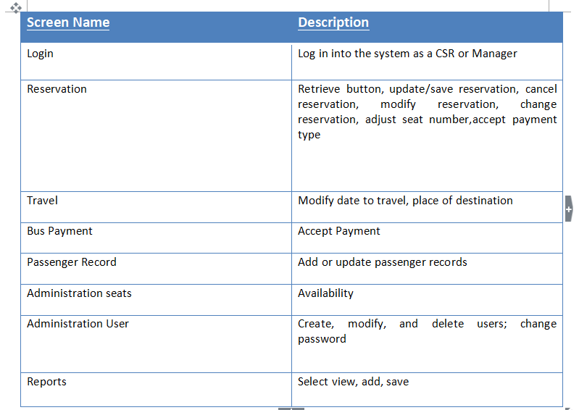

Hardware Interfaces

- A smart device with browser which support CGI ,HTML and Java-script.

Software Interfaces
The system shall interface with access database.

Communications Interfaces

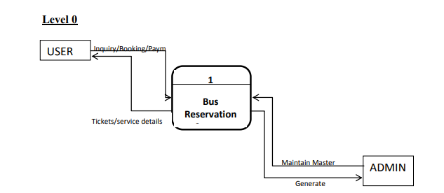

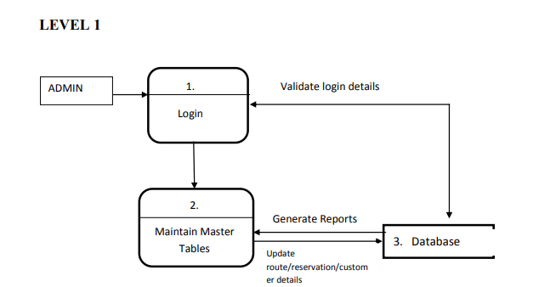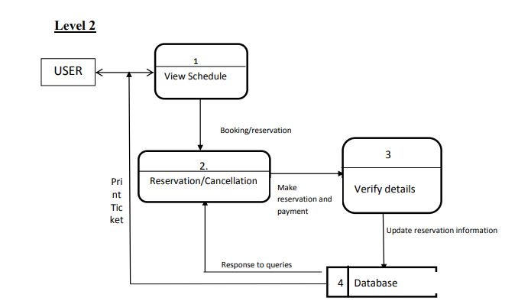

System Features

System Feature
3.5.1 Stimulus/Response Sequences
- Web application interfaces with user
Using input, users select a text field, the OS provides data entry methods
Inputs:
First Name - String, 30 characters max, not case sensitive
Last Name - String, 30 characters max, not case sensitive
Email - String, 30 characters max, not case sensitive, requires exactly 1 "@" sign and at least 1 "." symbol
Ticket Type - Drop down menu with "Single Use," "1 Day Pass," "3 Day Pass,"Week Pass." Defaults to "Single Use"
Credit card type - Drop down menu with "Visa," "Discover," "Master-card," "American Express." Defaults to "Select type."
Credit card number - String, Exactly 16 numeric characters
Expiration date month - String, Exactly 2 numeric characters
Expiration date year - String, Exactly 4 numeric characters
- Web application interfaces with database
When sending output "data," database returns 6 digit string "confirmation code"
Input:
Confirmation Code - String, 6 digit numeric code assigned by database as a key when receiving successful "data" input from Phone App. Sent back to phone application to display on screen
Using touch input, users touch an image button "Purchase", "Data" output is only sent once
Outputs:
Data - String, all text fields entered as inputs concatenated together, separated by semicolons
Database interfaces with Web application
database receives "data" string
Input:
Data - String, all text fields entered on phone concatenated together, separated by semicolons database sends "confirmation code" string back to Web application
Output:
Confirmation Code - String, 6 digit numeric code assigned by database as a key when receiving successful "data" input from Web App.
- Bus application interfaces with user
Using keyboard, users enter "confirmation code" provided upon successful purchase from Web app
Input:
Confirmation Code - String, 6 digit numeric code assigned by database as a key when receiving successful "data" input from Web App.
- Bus application interfaces with database
When sending output "code," database will return a Boolean indicating successful removal of given entry from database
Input:
Success - Boolean, returned from database, if "True" then display success message to user. If "False" display fail message to user.
Using mouse, users click an image button "Sign In", "Code" output is only sent once
Output:
Code - String, 6 digit numeric code, exact copy of "Confirmation Code." Sent to database to verify existence of user information
Database interfaces with Bus application
database receives "code" string
Input:
Code - String, 6 digit numeric code, used to check if string already exists in database as a key. When found, that entry in database is removed, and output "success" is returned.
database sends "success" Boolean back to bus application
Output:
Success - Boolean, "true" if entry specified by "code" was found and successfully removed. "False" if entry specified by "code" was not found. Database is unchanged if "Success" is false

V. Extra Features Of The Bus Management System
Any empty seat in the middle of the journey (would probably happen due to the user getting
off the bus due to the arrival of his destination) would be synchronized as needed.(i.e the
passenger that got off at a destination would leave a seat empty and thus another passenger
with that place as his boarding point would get that seat.)
3.5.2 Functional Requirements
- Open GUI on phone
- create window with all text fields and images and buttons
- Submit button is pushed
test validity of all user entered fields
verify all fields are entered
verify proper formatting for fields requiring formatting
display output to screen about outcome of verification
Send data to database
connect to database
consolidate all text fields into a string
send string to database
parse string to database fields
send confirmation back to application
display on screen success animation
- Open Check In App on bus
- create window with text field and button
- Submit button is pushed
test validity of user entered field
verify field is entered
verify proper formatting for field
display output to screen about outcome of verification
Send data to database
connect to database
search for code entered by user
remove user from database if entry is "Single Use Pass"
send confirmation back to application
display on screen success animation

Other Nonfunctional Requirements

Performance Requirements
- The system must be interactive and the delays involved must be less . ...
- Information transmission should be securely transmitted to server without any changes in information.
- Reliability.

Data Requirement
All data will be stored as Strings in the database. The only calculations that will be performed is the search implemented to check the "code" with all the entry Keys in the database. The only other methods that are run are the add and remove methods for entries in the database.

Security Requirements
Security is used to ensure credit card information as confidential and is not stored anywhere. The only location any user data is visible is when users enter in their information. System Administers are trained on customer privacy.

Safety Requirement

If there is extensive damage to a wide portion of the database due to catastrophic failure, such as a disk crash, the recovery method restores a past copy of the database that was backed up to archival storage (typically tape) and reconstructs a more current state by reapplying or redoing the operations of committed transactions from the backed up log, up to the time of failure.

Software Quality Attributes
- After each revision the system will be analyzed and compared with the system requirements designated by the client. We will than try to break the program with test cases.

- We will all be responsible for quality assurance. We will cross-analyze the system implementation with the System Requirements to verify system accuracy.

- All final documents will be reviewed for spelling errors, broken links, and any other issues that affect the quality of the document. Any errors found in either the system or supporting documents will be fixed at the time errors are found.
Appendix A: Data Dictionary
This SRS document is used to give details regarding Online Bus reservation System. In this all the functional and non-functional requirements are specified in-order to get a clear cut idea to develop a project.
Appendix B:Group Log
A group of five people was made to prepare the project for Software Engineering. A sub topic was decided upon as Online Bus Reservation System. The topic and the group members’ names were then given to the Instructor. All the four members then read the example srs document provided and searched for the requisite document for system. The Problem description, the purpose and the scope of the document was finalized.
Appendix C: Limitations
- A user must be a registered before booking a ticket.
- An un-registered user can only see our web app in view mode. None of the changes made by them will be updated in our database.

Appendix D: Constraints
I. A user can only be access our web app using internet services.
II. Database requirements will be limited.

Appendix D: Further scope
I. A user can book ticket by just using a feature phone.

